Functional Specification

**Group Members: Muhammad Cheema and Jeffin Domi**

**Analysis**

Welcome to the epic medieval remake of Space Invaders, King of the Hill!

King of the Hill is a strategic game that requires the player to control the royal archer, Tony Nevermiss, to save King Willy II from the Grey Runners.

**The Story**

Once upon a time, King Willy II left the castle on the hill to visit a nearby village, when suddenly, a group of Grey Runners surrounded him! The King yelled for help, and Tony Nevermiss, the kingdom’s top royal archer saw what happened. He shouted to the rest of the knights that the King has been captured, and they all run over to the barracks to get their weapons to save the king. The Grey Runners heard the call and decided to destroy the bridge so the knights can’t get them. the kings only hope is for the Tony Nevermiss to shoot them all down before it's too late!

**The Objective**

* You must defeat all the Grey Runners before they destroy the bridge and go off with the king.
* If they are defeated, you save the king from harm and you are awarded with great honor.
* If they reach the bridge, they will destroy it, take the king away, and the knights cannot save him.
* If you kill the king, you will be beheaded.

**Design**

**Broad Explanation of Gameplay**

King of the Hill is basically a version of space invaders but with a twist on the theme and actual game play.

**Game Play + Controls**

* The game starts out with title screen that gives the player three options: a “Story” button to read the story of the game plus its main objectives/rules, a “Controls” button to view the controls of the games. And a “Start” button requires the player the “Start” button, (or enter) to start the game.
* Once the game starts, the Grey Runners and King Willy II move in the same left - down - right - down motion as seen in Space Invaders.
* The player will use the Left and Right keys to move the archer, and press the Spacebar to shoot an arrow.
* If an arrow hits one of the Grey Runners, it will disappear, meaning you defeated that enemy.
* The player has to avoid hitting the king (which is the yellow/gold box). If an arrow hits the king, the player loses the game.
* If the Grey Runners reach the area where the bridge is, the player loses the game.
* If the player defeats all the Grey Runners they win the game.
* When the player wins/loses the game, a message should pop up saying one of the four phrases (depending on what happens):

1. “YOU DEFEATED THE GREY RUNNERS! YOU WIN!”
2. “”YOU KILLED THE KING! YOU LOSE!” “THE GREY RUNNERS DESTROYED THE BRIDGE! YOU LOSE!”

**Screen Shots**

(This is the start-up screen)

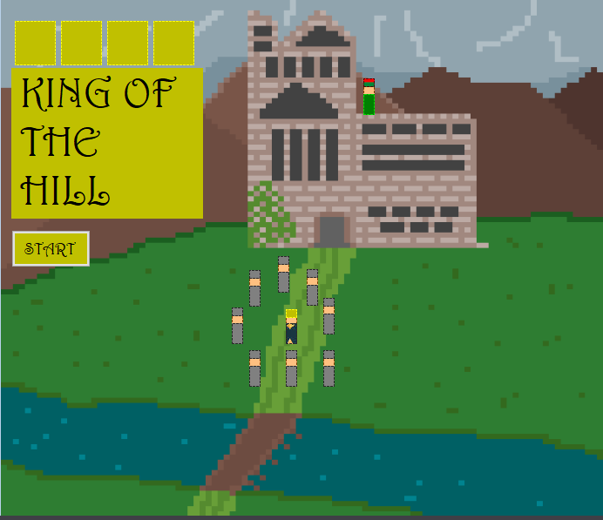

(CONTINUED BELOW)

(This is similar layout to the how actual game play will be like )

